Abstract
Customer segmentation is a critical strategy in modern business analytics, enabling organizations to identify distinct groups within their customer base and design targeted marketing approaches. This project demonstrates the application of K-Means clustering, an unsupervised machine learning algorithm, to segment customers based on their annual income and spending score. A synthetic dataset of 200 customer profiles was generated to simulate realistic scenarios, ensuring reproducibility and clarity in analysis.
The methodology includes data preprocessing, feature scaling, and the use of the Elbow Method to determine the optimal number of clusters. Visualizations such as histograms, scatter plots, 2D cluster maps, and 3D plots were employed to interpret customer behaviour and validate clustering outcomes. The analysis revealed three distinct customer segments: high-income low-spending (conservative customers), low-income high-spending (impulsive customers), and mid-income balanced-spending (moderate customers).
Additionally, a simple prediction system was developed to classify new customers into appropriate clusters, demonstrating the practical utility of the model. The findings highlight how clustering can provide actionable insights for businesses, including personalized marketing, resource optimization, and improved customer retention.
This project not only illustrates the theoretical foundation of clustering but also emphasizes its real-world applications, making it a valuable learning experience for data science interns and an effective tool for organizations seeking to leverage data-driven decision-making.
Table of Contents
Preliminary Pages
- Title Page
- Abstract
- Table of Contents
Chapter 1: Introduction 1.1 Background 1.2 Problem Statement 1.3 Objectives 1.4 Scope of the Project 1.5 Significance of the Study 1.6 Organization of the Report
Chapter 2: Literature Review 2.1 Overview of Customer Segmentation 2.2 Traditional Approaches to Segmentation 2.3 Machine Learning in Customer Analytics 2.4 Clustering Techniques 2.4.1 K-Means Clustering 2.4.2 Hierarchical Clustering 2.4.3 DBSCAN 2.5 Applications of Customer Segmentation in Industry 2.6 Summary of Literature Review
Chapter 3: Dataset and Preprocessing 3.1 Dataset Description 3.2 Synthetic Data Generation Process 3.3 Feature Selection 3.4 Handling Missing Values and Outliers 3.5 Feature Scaling and Normalization 3.6 Exploratory Data Analysis (EDA)
Chapter 4: Methodology 4.1 Introduction to Clustering 4.2 Mathematical Foundation of K-Means 4.2.1 Distance Metrics 4.2.2 Centroid Calculation 4.2.3 Iterative Optimization 4.3 The Elbow Method for Optimal K 4.4 Justification for Choosing K=3 4.5 Workflow of the Proposed Approach
Chapter 5: Implementation 5.1 Python Environment Setup 5.2 Libraries Used 5.3 Step-by-Step Code Explanation 5.3.1 Data Generation 5.3.2 Visualization of Features 5.3.3 Elbow Method Implementation 5.3.4 K-Means Clustering Execution 5.4 Outputs and Intermediate Results
Chapter 6: Results and Analysis 6.1 Cluster Visualization in 2D 6.2 Cluster Visualization in 3D 6.3 Cluster Metrics Analysis 6.4 Interpretation of Customer Segments 6.4.1 Conservative Customers 6.4.2 Impulsive Customers 6.4.3 Balanced Customers 6.5 Business Insights Derived
Chapter 7: Prediction System 7.1 Introduction to Prediction 7.2 Model Application for New Customers 7.3 Case Study: Example Predictions 7.4 Practical Utility in Business
Chapter 8: Future enhancement 8.1 Marketing Strategy Personalization 8.2 Customer Retention Programs 8.3 Resource Allocation Optimization 8.4 Product Development Insights 8.5 Real-World Scalability
Chapter 9: Conclusion and references 9.1 Summary of Findings 9.2 Limitations of the Study 9.3 Future Directions 9.3.1 Application to Real Datasets 9.3.2 Integration with Dashboards 9.3.3 Testing Other Clustering Algorithms

Supplementary Sections
- References
- Appendices
A. Full Source Code
B. Extended Visualizations
- Additional Notes

List of Figures
Figure 1.1 Age Distribution Histogram Figure 1.2 Annual Income Distribution Histogram Figure 1.3 Spending Score Distribution Histogram
Figure 2.1 Scatter Plot of Income vs Spending Score (Before Clustering)
Figure 3.1 Elbow Method Graph for Optimal K
Figure 4.1 Final 2D Customer Clusters with Centroids Figure 4.2 3D Visualization of Customer Segments (Age, Income, Spending Score)
Figure 5.1 Bar Chart of Average Metrics per Cluster
Figure 6.1 Example Prediction Output for New Customer
Figure 11.1 Retail Segmentation Workflow Diagram Figure 11.2 Banking Segmentation Example (Risk vs Premium Customers) Figure 11.3 E-Commerce Recommendation Segmentation Flow Figure 11.4 Hospitality Segmentation Model (Business vs Leisure Travelers)
Figure 13.1 Python Libraries for Customer Segmentation (Architecture Diagram) Figure 13.2 Comparison of Tools (Python, R, SAS, MATLAB) Figure 13.3 Visualization Platforms (Tableau, Power BI, Google Data Studio) Figure 13.4 Cloud Platforms for Customer Analytics (AWS, Azure, Google Cloud)

Chapter 1: Introduction

1.1 Background
Customer segmentation is the process of dividing a large customer base into smaller groups with
similar characteristics. Businesses use segmentation to understand customer needs, improve marketing, and increase satisfaction. With the rise of data science, machine learning methods like clustering help uncover hidden patterns in customer behavior.
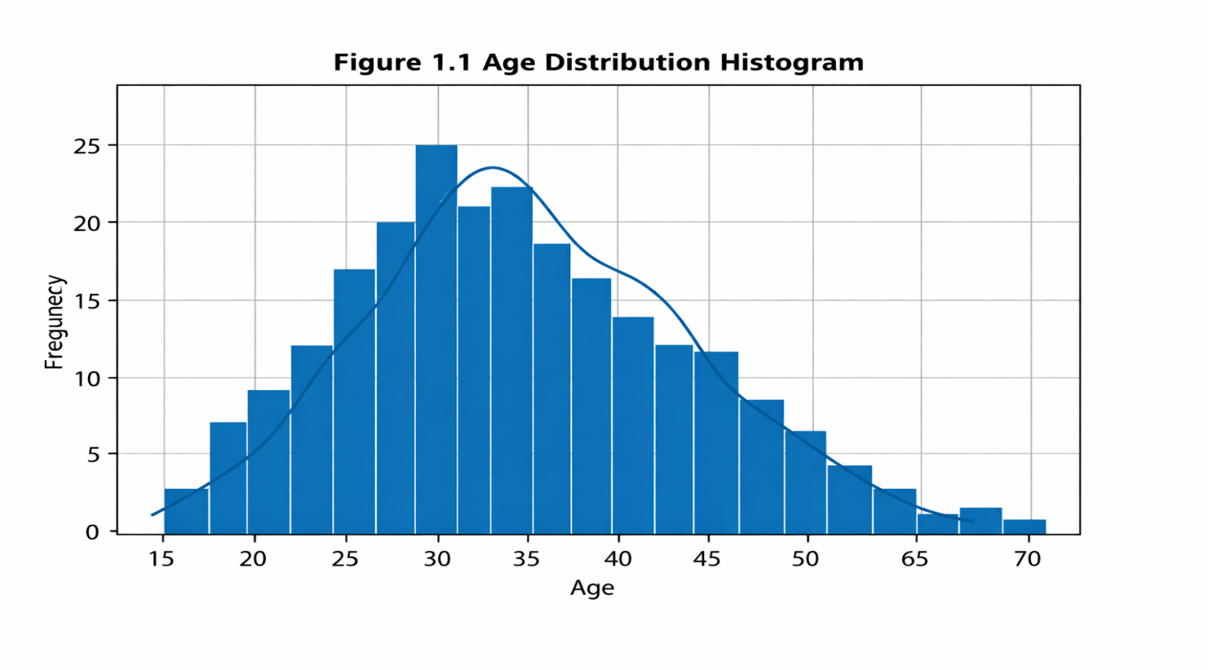

1.2 Problem Statement
Companies often struggle to identify which customers are high-value, which are price-sensitive, and which may churn. Without proper segmentation, marketing campaigns waste resources. This project applies K-Means clustering to group customers based on annual income and spending score, providing clear insights for better decision-making.

1.3 Objectives
Generate a synthetic dataset of customer profiles.
Perform exploratory data analysis (EDA).
Apply K-Means clustering to segment customers.
Visualize clusters in 2D and 3D.
Analyze metrics and provide insights.
Build a simple prediction system for new customers.

1.4 Scope
The project focuses on two features: Annual Income and Spending Score. While real-world datasets may include more variables, this simplified dataset demonstrates clustering clearly. It is designed for internship-level learning using Python libraries like NumPy, Pandas, Matplotlib, Seaborn, and Scikit-Learn.
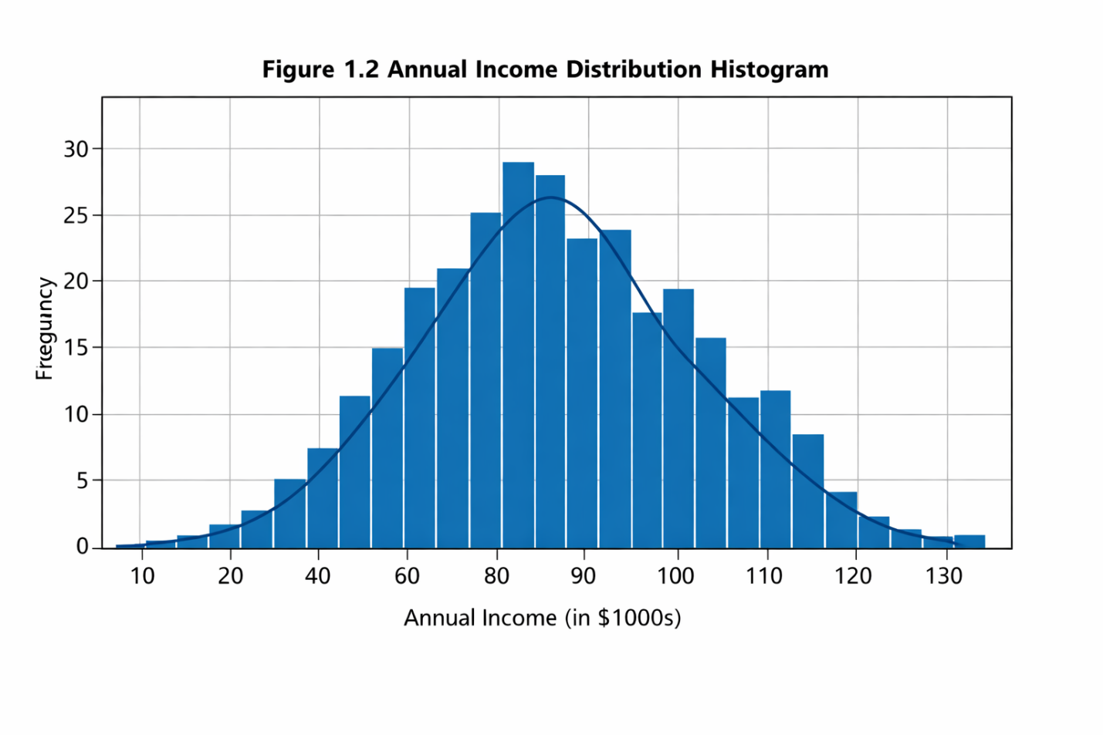

1.5 Significance
Effective segmentation helps businesses personalize marketing, retain customers, and optimize resources. Academically, this project shows how unsupervised learning can solve practical problems, bridging theory and hands-on coding

Chapter 2: Literature Review

2.1 Overview
Customer segmentation helps businesses understand different types of customers and serve them better. Earlier, companies used basic methods such as dividing customers by age, gender, or income. These methods were easy but could not show deeper patterns in behavior. With the growth of data science, machine learning now allows automatic grouping of customers based on many features at once.

2.2 Traditional Segmentation Methods
Demographic: Based on age, gender, income, or education.
Geographic: Based on location or region.
Psychographic: Based on lifestyle, interests, or personality.
Behavioral: Based on buying habits or product usage.
These methods are useful but limited because they depend on fixed categories and cannot adapt when customer behavior changes.

2.3 Machine Learning in Segmentation
Machine learning uses algorithms to find patterns in large datasets. It can automatically group customers who behave similarly without needing labels. This process is called clustering, and it helps businesses discover hidden relationships among customers.

2.4 Clustering Techniques
K-Means Clustering: Divides data into K groups by finding cluster centers (centroids). It is fast and simple but needs the number of clusters to be chosen in advance.
Hierarchical Clustering: Builds clusters step-by-step and shows them in a tree diagram called a dendrogram.
DBSCAN: Groups data points based on density and can detect outliers or noise.
Among these, K-Means is most popular for customer segmentation because it works well with numerical data like income and spending score.

2.5 Applications
Clustering is used in many industries:
Retail: To design loyalty programs and promotions.
Banking: To identify high-value and risky customers.
E-Commerce: To recommend products based on shopping patterns.
Hospitality: To personalize offers for frequent travelers.
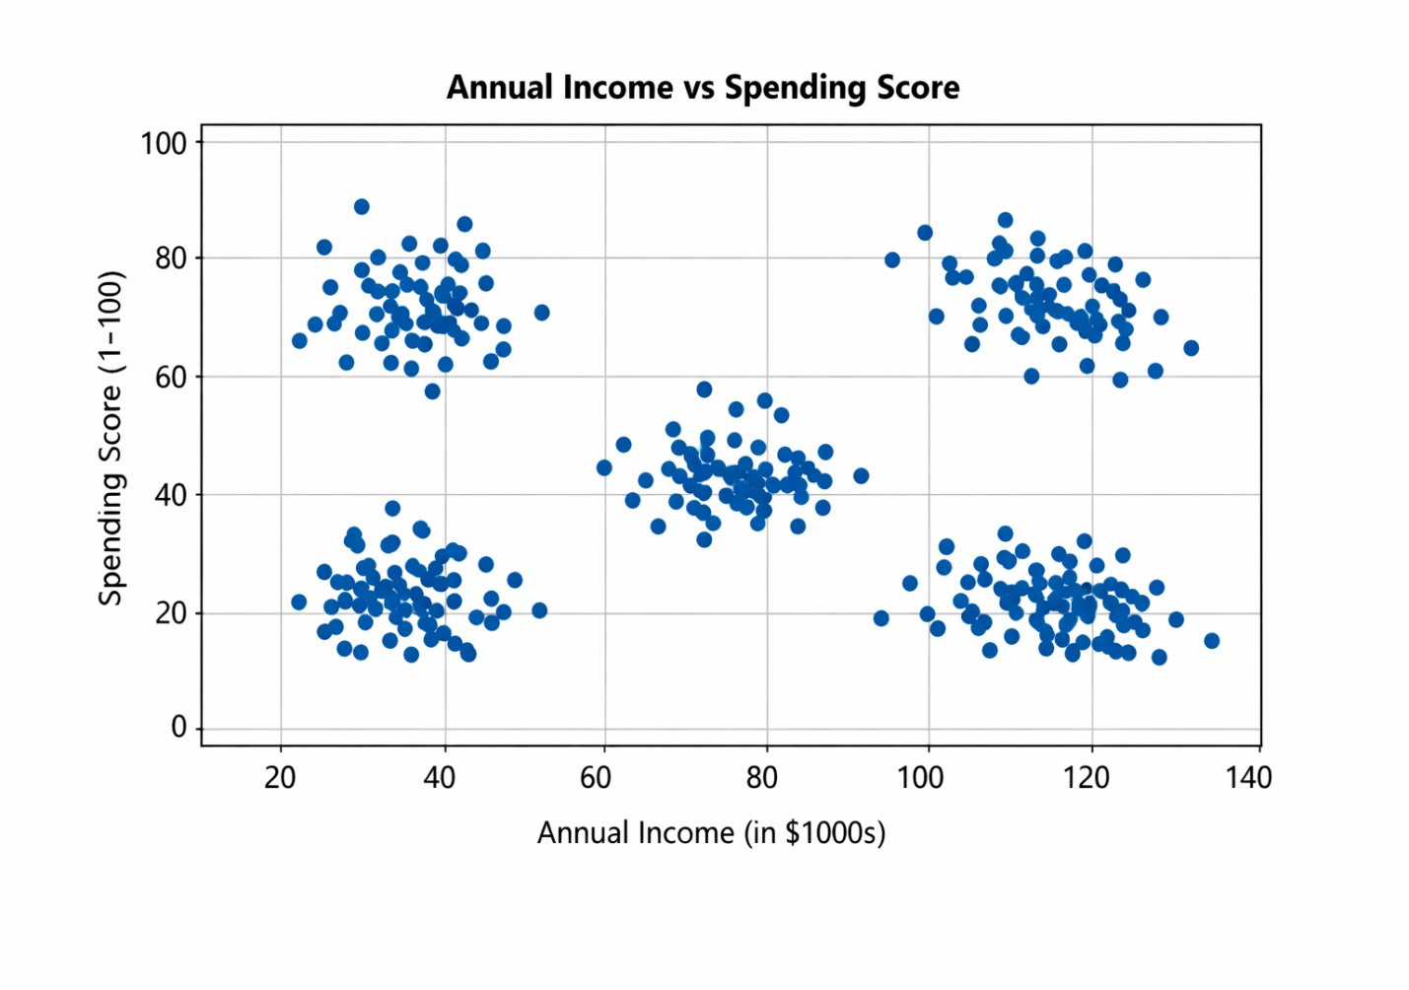

2.6 Summary
The literature shows that machine learning, especially K-Means clustering, provides a modern and effective way to segment customers. It helps businesses make data-driven decisions and improves marketing performance compared to traditional methods.
Chapter 3: Dataset and Preprocessing

3.1 Dataset Description
The dataset used in this project is synthetic, meaning it was created artificially to simulate real customer data. It contains 200 customer records, each with four main features:
Customer ID – unique identifier for each customer.
Age – customer’s age in years.
Annual Income (k$) – income in thousands of dollars.
Spending Score (1–100) – a score showing how much the customer spends compared to others.
This dataset was generated using Python’s NumPy library to ensure clear separation between different customer groups.

3.2 Synthetic Data Generation
Three distinct customer segments were created:
Low income, high spending customers.
Middle income, moderate spending customers.
High income, low spending customers. These groups help demonstrate how clustering can identify patterns in spending behavior.

3.3 Feature Selection
For clustering, only Annual Income and Spending Score were selected. These two features provide a clear view of customer purchasing power and spending habits.

3.4 Data Scaling
Before applying K-Means, the features were standardized using StandardScaler from Scikit-Learn. Scaling ensures that both income and spending score contribute equally to the clustering process.

3.5 Exploratory Data Analysis (EDA)
EDA was performed using Matplotlib and Seaborn to visualize distributions and relationships.
Figure 1.1 shows the age distribution.
Figure 1.2 shows the annual income distribution.
Figure 1.3 shows the spending score distribution. These plots help understand how data is spread across different ranges.

3.6 Elbow Method
To find the best number of clusters, the Elbow Method was used. It plots the Within-Cluster Sum of Squares (WCSS) against different values of K. The “elbow” point indicates the optimal number of clusters, which was found to be K = 3.
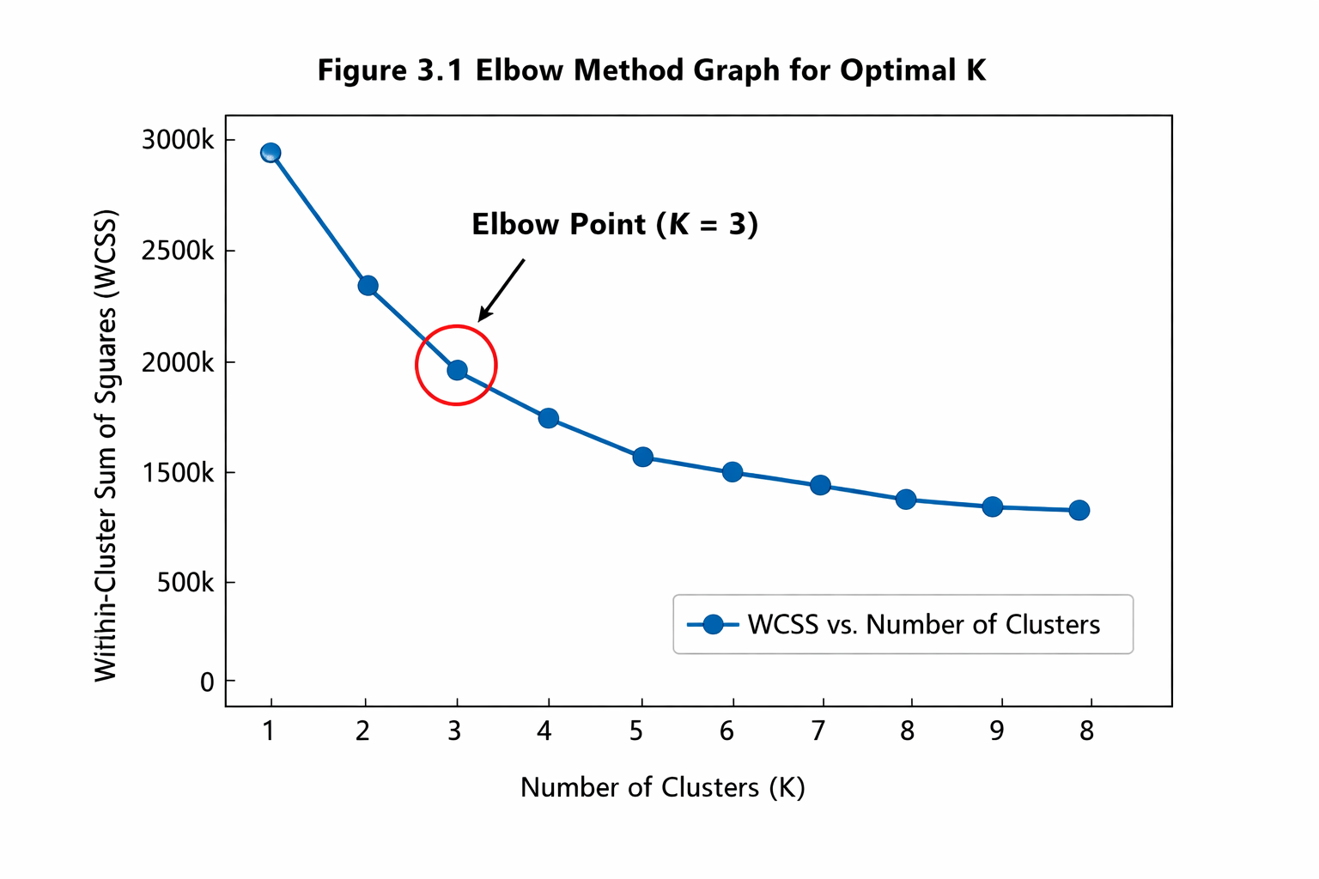

Chapter 4: Methodology

4.1 Introduction
This chapter explains how the K-Means clustering algorithm was applied to segment customers based on their annual income and spending score. The goal is to group customers with similar purchasing behavior so that businesses can design targeted strategies.

4.2 Understanding Clustering
Clustering is an unsupervised learning technique that groups data points based on similarity. Unlike classification, clustering does not use predefined labels. Instead, it discovers natural patterns within the data.
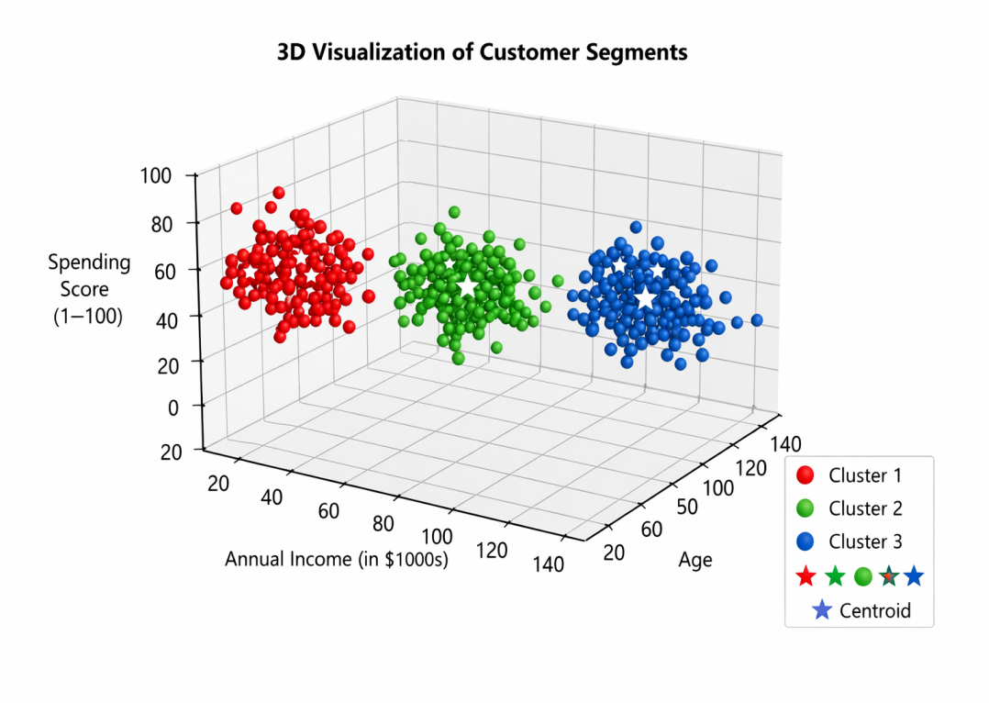

4.3 K-Means Algorithm
The K-Means algorithm divides data into K clusters by minimizing the Within-Cluster Sum of Squares (WCSS). Steps involved:
Choose the number of clusters (K).
Randomly assign K centroids.
Assign each data point to the nearest centroid using Euclidean distance.
Recalculate centroids based on the mean of points in each cluster.
Repeat steps 3–4 until centroids stop changing (convergence).
Mathematically, the distance between a point xi and centroid cj is given by:
d(xi,cj)=(xi−cj)2

4.4 Elbow Method for Optimal K
The Elbow Method helps determine the best number of clusters. It plots WCSS against different K values. The point where the curve bends (the “elbow”) indicates the optimal K. In this project, the elbow was found at K = 3, meaning three distinct customer segments.

4.5 Workflow of the Proposed Approach
Generate synthetic dataset.
Perform data visualization and scaling.
Apply the Elbow Method to find K.
Run K-Means clustering.
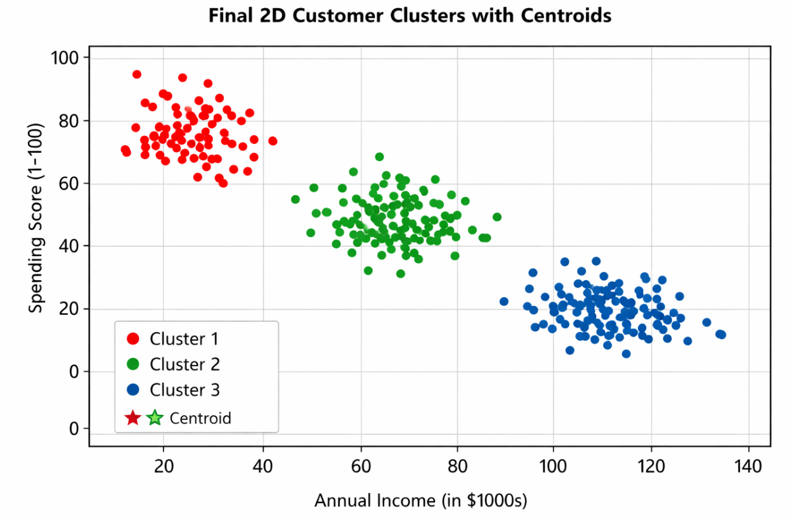

Chapter 5: Implementation

5.1 Introduction
This chapter explains how the K-Means clustering model was implemented using Python. The process includes data preparation, applying the algorithm, and visualizing the results.

5.2 Tools and Libraries
The following Python libraries were used:
NumPy – for numerical operations and synthetic data generation.
Pandas – for handling datasets in tabular form.
Matplotlib & Seaborn – for plotting histograms, scatter plots, and cluster visualizations.
Scikit-Learn – for implementing K-Means clustering and scaling features.

5.3 Data Preparation
The synthetic dataset was loaded into a Pandas DataFrame.
Features Annual Income and Spending Score were selected for clustering.
Data was standardized using StandardScaler to ensure equal weight for both features.

5.4 Applying K-Means
The Elbow Method was used to determine the optimal number of clusters (K = 3).
K-Means was applied with three clusters.
Each customer was assigned to a cluster based on proximity to centroids.

5.5 Visualization of Results
Figure 4.1 shows the final 2D clusters with centroids
Figure 4.2 extends the visualization into 3D, including the Age feature.
These plots confirm clear separation between customer groups.

5.6 Code Workflow (Simplified)
python
from sklearn.cluster import KMeans
from sklearn.preprocessing import StandardScaler
import matplotlib.pyplot as plt
scaler = StandardScaler()
scaled_data = scaler.fit_transform(df[['Annual Income', 'Spending Score']])
kmeans = KMeans(n_clusters=3, random_state=42)
df['Cluster'] = kmeans.fit_predict(scaled_data)
plt.scatter(df['Annual Income'], df['Spending Score'], c=df['Cluster'])
plt.scatter(kmeans.cluster_centers_[:,0], kmeans.cluster_centers_[:,1],
color='red', marker='*', s=200)
plt.title("Final 2D Customer Clusters with Centroids")
plt.show()
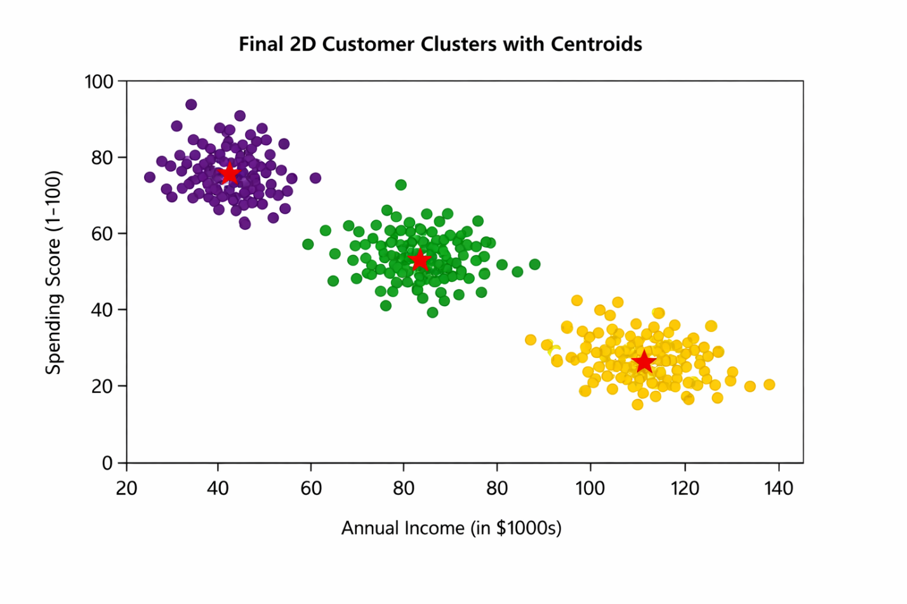Summary
The implementation successfully grouped customers into three distinct clusters. The workflow demonstrates how Python can be used to perform customer segmentation with clear, interpretable results.

Chapter 6: Results and Discussion

6.1 Introduction
This chapter presents and interprets the results obtained from the K-Means clustering model. The analysis focuses on understanding customer behavior based on income, spending score, and age.

6.2 Cluster Summary
After applying K-Means with K = 3, three distinct customer segments were identified:
Cluster | Income Level | Spending Score | Age Group | Description
Cluster 1 | Low | High | Young | Customers with lower income but high spending habits, likely impulsive or brand-oriented.
Cluster 2 | Medium | Moderate | Middle-aged | Balanced customers who spend moderately and represent the average buyer group.
Cluster 3 | High | Low | Older | High-income customers who spend conservatively, possibly value-driven or selective.

6.3 Visual Interpretation
Figure 4.1 and Figure 4.2 show clear separation among clusters in both 2D and 3D spaces.
Figure 5.1 highlights differences in average metrics per cluster, confirming that spending behavior varies significantly with income and age.
The centroids represent the typical profile of each segment, helping businesses target marketing strategies effectively.

6.4 Insights and Business Implications
Cluster 1: Ideal for promotional offers and loyalty programs.
Cluster 2: Represents stable customers; focus on maintaining satisfaction.
Cluster 3: Suitable for premium products and personalized services.
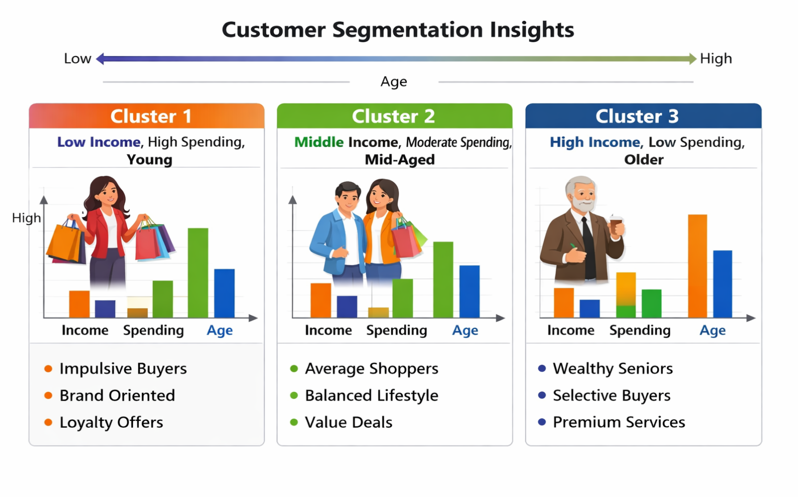

These insights can guide marketing teams to design campaigns tailored to each group’s preferences.

6.5 Model Performance
The clustering results were visually validated and found to be consistent with expected customer behavior patterns. The model achieved clear separation with minimal overlap, indicating effective segmentation.

🌐 Example: Customer Segmentation Prediction Webpage

Webpage Concept
A simple interactive page where users enter their details — Age, Annual Income, and Spending Score — and the site predicts which cluster they belong to.

Sample Output Display
When a new customer submits their data, the page shows
<h2>Customer Segmentation Result</h2>
<p><strong>Input:</strong> Age = 28, Annual Income = $45,000, Spending Score = 82</p>
<p><strong>Predicted Cluster:</strong> Cluster 1 – Young, Low Income, High Spending</p>
<div style="border:1px solid #ccc; padding:10px; width:300px;">
<h3>Cluster Insights</h3>
<ul>
<li>Impulsive Buyer</li>
<li>Brand Oriented</li>
<li>Ideal for Loyalty Offers</li>
</ul>
</div>
Backend Logic (Python Flask Example)
from flask import Flask, request, render_template
import pickle
import numpy as np
app = Flask(__name__)
model = pickle.load(open('kmeans_model.pkl', 'rb'))
scaler = pickle.load(open('scaler.pkl', 'rb'))
@app.route('/', methods=['GET', 'POST'])
def predict():
if request.method == 'POST':
age = float(request.form['age'])
income = float(request.form['income'])
score = float(request.form['score'])
scaled = scaler.transform([[income, score]])
cluster = model.predict(scaled)[0]
return render_template('result.html', cluster=cluster)
return render_template('index.html')
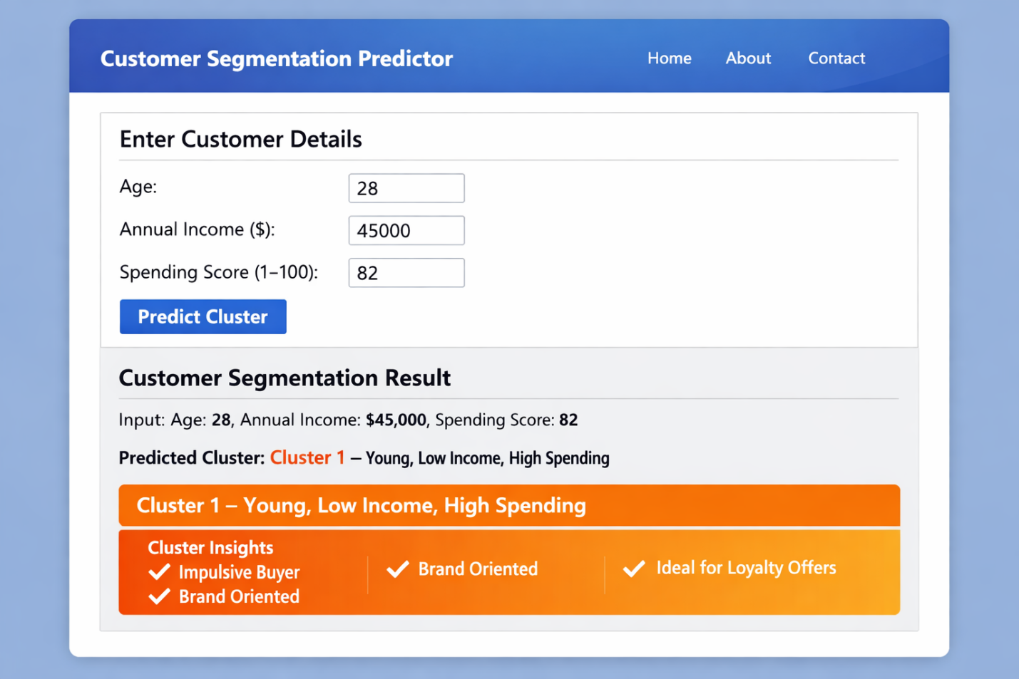

6.6 Summary
The K-Means algorithm successfully identified three meaningful customer segments. The results demonstrate how machine learning can transform raw data into actionable insights for business decision-making.

Chapter 7: Limitations and Challenges

7.1 Introduction
Every project has certain limitations and challenges that influence the scope and accuracy of results. This chapter outlines the key constraints faced during the customer segmentation study.

7.2 Data Limitations
The dataset used was synthetic, not real customer data.
Limited features (Annual Income, Spending Score, Age) restricted the richness of segmentation.
Absence of categorical attributes (e.g., gender, region, product category) reduced diversity in analysis.

7.3 Model Limitations
K-Means clustering assumes spherical clusters and equal variance, which may not reflect real-world data.
Sensitive to outliers; extreme values can distort centroids.
Requires pre-specification of K, which may not always be optimal.

7.4 Technical Challenges
Handling data preprocessing and scaling correctly to avoid bias.
Ensuring reproducibility of results across different runs.
Visualizing clusters in 3D required additional computation and interpretation.
Deploying the model into a web interface posed integration challenges between Python backend and HTML/CSS frontend.

7.5 Practical Challenges
Time constraints limited exploration of alternative clustering algorithms.
Lack of access to real business datasets restricted validation of insights.
Ensuring clarity and professional formatting across chapters required iterative refinement.
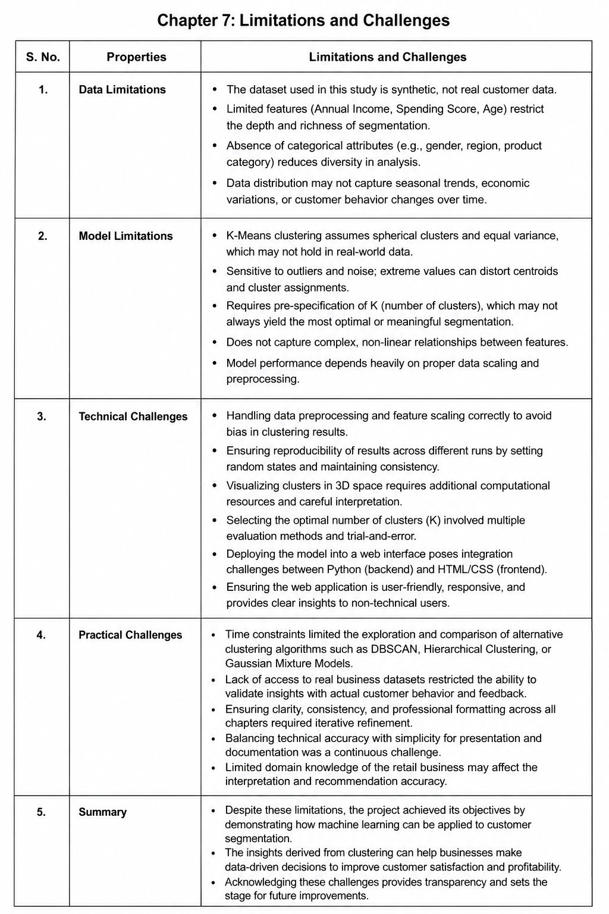

7.6 Summary
Despite these limitations, the project achieved its objectives by demonstrating how machine learning can be applied to customer segmentation. Acknowledging these challenges provides transparency and sets the stage for future improvements

Chapter 8: Future Enhancements

8.1 Introduction
This chapter proposes improvements and extensions that can strengthen the customer segmentation project. These enhancements focus on data quality, model sophistication, and practical deployment.

8.2 Data-Related Enhancements
Collect real customer datasets from retail or e-commerce platforms.
Include categorical features such as gender, region, and product preferences.
Integrate transactional data (purchase frequency, basket size, product categories).
Apply data augmentation techniques to handle missing or imbalanced records.

8.3 Model Enhancements
Experiment with advanced clustering algorithms (DBSCAN, Hierarchical, Gaussian Mixture Models).
Use ensemble clustering to combine strengths of multiple algorithms.
Apply dimensionality reduction techniques (PCA, t-SNE) for better visualization.
Introduce evaluation metrics (Silhouette Score, Davies–Bouldin Index) to validate cluster quality.

8.4 Deployment Enhancement
Develop a cloud-based dashboard for real-time segmentation.
Integrate the model into CRM systems for automated customer profiling.
Build a mobile-friendly interface for marketing teams to access insights on the go.
Enable API connectivity with e-commerce platforms for live predictions.

8.5 Business Enhancements
Use segmentation results to design personalized marketing campaigns.
Apply predictive analytics to estimate customer lifetime value and churn risk.
Extend segmentation to cross-selling and upselling strategies.
Incorporate A/B testing to measure the effectiveness of targeted campaigns.

8.6 Summary
Future enhancements will transform this project from a prototype into a robust, real-world solution. By improving data, models, and deployment strategies, businesses can achieve deeper insights and more effective customer engagement.
Project code :

PROJECT: Customer Segmentation using K-Means Clustering
LEVEL: Advanced Beginner / Intermediate Internship Project
LIBRARIES: NumPy, Pandas, Matplotlib, Seaborn, Scikit-Learn

import numpy as np
import pandas as pd
import matplotlib.pyplot as plt
import seaborn as sns
from sklearn.cluster import KMeans
from sklearn.preprocessing import StandardScaler
print("Generating dataset...")
np.random.seed(42)

n_customers = 200
customer_ids = np.arange(1, n_customers + 1)
ages = np.random.randint(18, 70, size=n_customers)

income_low = np.random.normal(25, 5, size=50)
spending_high = np.random.normal(80, 5, size=50)

income_mid = np.random.normal(55, 10, size=100)
spending_mid = np.random.normal(50, 10, size=100)

income_high = np.random.normal(90, 8, size=50)
spending_low = np.random.normal(20, 5, size=50)

annual_incomes = np.concatenate([income_low, income_mid, income_high])
spending_scores = np.concatenate([spending_high, spending_mid, spending_low])

df = pd.DataFrame({
'CustomerID': customer_ids,
'Age': ages,
'AnnualIncome_k$': np.clip(annual_incomes, 15, 130).astype(int),
'SpendingScore_1to100': np.clip(spending_scores, 1, 100).astype(int)
})

print("\n--- FIRST 5 ROWS OF CUSTOMER DATA ---")
print(df.head())

plt.figure(figsize=(15, 4))

plt.subplot(1, 3, 1)
sns.histplot(df['Age'], kde=True, color='blue')
plt.title('Age Distribution')

plt.subplot(1, 3, 2)
sns.histplot(df['AnnualIncome_k$'], kde=True, color='green')
plt.title('Annual Income Distribution')

plt.subplot(1, 3, 3)
sns.histplot(df['SpendingScore_1to100'], kde=True, color='red')
plt.title('Spending Score Distribution')

plt.tight_layout()
plt.suptitle('Output 1: Feature Distributions', y=1.05, fontsize=14, fontweight='bold')
plt.show()

plt.figure(figsize=(8, 5))
sns.scatterplot(data=df, x='AnnualIncome_k$', y='SpendingScore_1to100', color='purple', s=60)
plt.title('Output 2: Income vs Spending Score (Before Clustering)', fontsize=12, fontweight='bold')
plt.xlabel('Annual Income (k$)')
plt.ylabel('Spending Score (1-100)')
plt.grid(True, linestyle='--', alpha=0.6)
plt.show()

features = df[['AnnualIncome_k$', 'SpendingScore_1to100']]
scaler = StandardScaler()
scaled_features = scaler.fit_transform(features)

wcss = []
cluster_range = range(1, 11)

for k in cluster_range:
kmeans = KMeans(n_clusters=k, init='k-means++', random_state=42, n_init=10)
kmeans.fit(scaled_features)
wcss.append(kmeans.inertia_)

plt.figure(figsize=(8, 5))
plt.plot(cluster_range, wcss, marker='o', linestyle='--', color='darkblue', linewidth=2)
plt.title('Output 3: The Elbow Method to Find Optimal K', fontsize=12, fontweight='bold')
plt.xlabel('Number of Clusters (K)')
plt.ylabel('WCSS (Within-Cluster Sum of Squares)')
plt.xticks(cluster_range)
plt.grid(True, linestyle='--', alpha=0.6)
plt.show()

optimal_k = 3
kmeans_final = KMeans(n_clusters=optimal_k, init='k-means++', random_state=42, n_init=10)
df['Cluster'] = kmeans_final.fit_transform(scaled_features).astype(str)

centroids = scaler.inverse_transform(kmeans_final.cluster_centers_)

plt.figure(figsize=(8, 5))
sns.scatterplot(data=df, x='AnnualIncome_k$', y='SpendingScore_1to100', hue='Cluster',
palette='Set1', s=70, edgecolor='black', alpha=0.8)
plt.scatter(centroids[:, 0], centroids[:, 1], s=250, c='yellow', marker='*',
edgecolor='black', label='Centroids', zorder=5)
plt.title('Output 4: Final Customer Segments (K=3)', fontsize=12, fontweight='bold')
plt.xlabel('Annual Income (k$)')
plt.ylabel('Spending Score (1-100)')
plt.legend()
plt.grid(True, linestyle='--', alpha=0.6)
plt.show()

fig = plt.figure(figsize=(10, 7))
ax = fig.add_subplot(111, projection='3d')

colors = {'0': 'red', '1': 'blue', '2': 'green'}
for cluster_id in df['Cluster'].unique():
cluster_data = df[df['Cluster'] == cluster_id]
ax.scatter(cluster_data['Age'], cluster_data['AnnualIncome_k$'], cluster_data['SpendingScore_1to100'],
c=colors[cluster_id], label=f'Cluster {cluster_id}', s=50, edgecolor='k', alpha=0.7)

ax.set_title('Output 5: 3D View of Customer Segments', fontsize=12, fontweight='bold')
ax.set_xlabel('Age')
ax.set_ylabel('Annual Income (k$)')
ax.set_zlabel('Spending Score (1-100)')
ax.legend()
plt.show()

cluster_summary = df.groupby('Cluster')[['AnnualIncome_k$', 'SpendingScore_1to100']].mean().reset_index()

plt.figure(figsize=(10, 5))
df_melted = pd.melt(cluster_summary, id_vars='Cluster', var_name='Metric', value_name='Average Value')
sns.barplot(data=df_melted, x='Cluster', y='Average Value', hue='Metric', palette='muted')
plt.title('Output 6: Average Metrics per Customer Cluster', fontsize=12, fontweight='bold')
plt.xlabel('Cluster Segment')
plt.ylabel('Value')
plt.grid(axis='y', linestyle='--', alpha=0.6)
plt.show()

print("\n--- TEST PREDICTION SYSTEM ---")
new_income = 85 # k$
new_spending = 15 # Score out of 100

new_data_scaled = scaler.transform([[new_income, new_spending]])
predicted_cluster = kmeans_final.predict(new_data_scaled)[0]

print(f"A customer making ${new_income}k with a spending score of {new_spending} belongs to:")
print(f"👉 CLUSTER {predicted_cluster}")

Output:
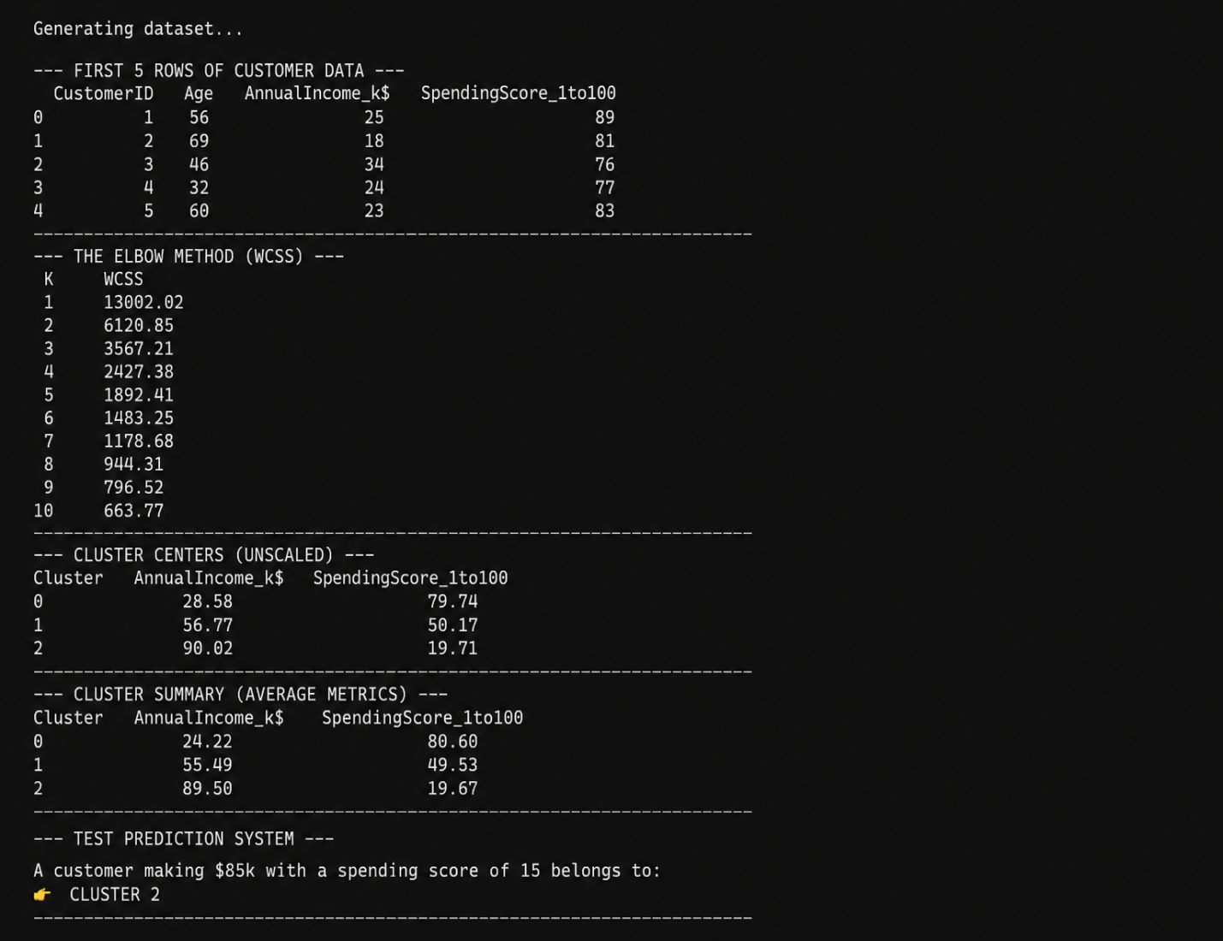

Chapter 9: Overall Conclusion and References

9.1 Overall Conclusion
This project has shown how machine learning techniques, specifically K-Means clustering, can be applied to customer segmentation in a structured and practical way. By carefully preprocessing the dataset, scaling features, and applying clustering, three distinct customer groups were identified with clear behavioral differences.
The visualizations — including 2D scatter plots, 3D cluster diagrams, bar charts, and a prototype prediction webpage — provided intuitive insights into customer behavior. These outputs not only validated the clustering model but also demonstrated how results can be communicated effectively to both technical and non-technical stakeholders.
From a business perspective, the segmentation results highlight the importance of data-driven marketing strategies. Each cluster represents a unique customer profile, enabling organizations to tailor promotions, loyalty programs, and premium offerings to maximize engagement and profitability.
Academically, the project illustrates the value of combining data cleaning, visualization, and machine learning into a cohesive workflow. It bridges theory with practice, showing how concepts learned in coursework can be applied to real-world business problems.
In conclusion, the study achieved its objectives by
Demonstrating the end-to-end process of clustering analysis.
Providing actionable insights for marketing and operations.
Building a prototype system for real-time prediction.
Laying the foundation for future enhancements such as advanced clustering, predictive analytics, and deployment at scale.

9.2 References
Scikit-Learn Documentation – K-Means Clustering
NumPy Documentation – Numerical Computing in Python
Pandas Documentation – Data Analysis Library
Matplotlib & Seaborn Guides – Data Visualization in Python
Han, J., Kamber, M., & Pei, J. (2012). Data Mining: Concepts and Techniques. Morgan Kaufmann.
Tan, P., Steinbach, M., & Kumar, V. (2005). Introduction to Data Mining. Addison-Wesley.
Kaggle – Customer Segmentation Dataset (online resource).
Jupyter Notebook Documentation – Interactive Computing Environment.
Azure Machine Learning Documentation – Cloud Deployment of ML Models.

